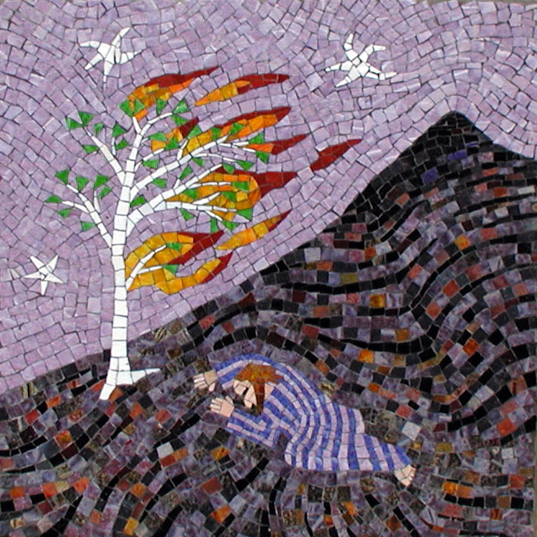
Details of a course near you:
Have You
seen a
Burning Bush?
What does God want
you
to do
with your life?
“Have you seen a
Burning Bush?”
is part of the
After Sunday Project.

www.aftersunday.org.uk

After Sunday, based in the North East of England, is a project which aims to
to strengthen the connection between faith, work and the world.

It is particularly concerned to encourage
everyone to explore their Christian vocations and sense of calling, and think about how they live out their faith in their daily lives.

Details of a course near you:

Venue :

Time :

Dates :

Other Information :

fff


Contact the
After Sunday Project:
admin@aftersunday.org.uk

Tel. (01325)361572

After Sunday
Sundial Cottage.
7 Haughton Green,
Darlington
Co Durham DL1 2DD

Front illustration
"Moses and the Burning Bush" by artist Joe Moorman 2003 www.riversonfineart.com



I wonder……
Will this course help me?
“I found I had feelings and opinions I didn’t know I had.”
“Anyone can do this course even if you haven’t done one before.”
“I learned that vocation is not about having a job at church – it is about being the ‘real you’.”
“It is transforming to see how God is at work in our lives in ordinary ways.”
“This was a thought provoking and challenging course but deeply affirming.”
"Excellent.
This course helps you see your gifts and then gives you the confidence to use them."
“I was thrilled at the end of the course with the outcome, as it has given me confirmation and a greater confidence of my calling.”

“I would recommend it to anyone who is serious about Christian discipleship and who wants to discover more about the person God is calling them to be.”

“The course really helped us to understand and encourage each other.”
- How I should make sense of my faith as a whole?
- What it is that God keeps niggling me to do?
- What is my purpose and how best to live it out in daily life?
- How best to live out my vocation in the world
This course offers:

- A way of thinking through vocation in the widest sense of the word
- Shows how the idea of ‘vocation’ is for everyone
- The chance to work with a group of like-minded individuals to think these questions through together
- A focus on not just doing ‘churchy’ things. It is about affirming your whole life and your work in the world
- A way of putting faith, work and life back together
- Think about vocation as more than a just a job

The course has 5 elements :

1. Introduction to Vocation
This session explores what vocation means for everyone and looks at examples of vocation in the Bible.

2. My Core Purpose
This session explores our core purpose as human beings and who we are uniquely made to be

3. Call to Attend
This session explores what it may be in the world that God is calling us to attend to, as part of his mission of love to the world

4. Identifying Our Mission
This session helps to clarify our own sense of mission and the actions that we are being called to take in response to it.

5. Supporting Each Other
This session explores how as a church community we can support and encourage each other in exercising our vocations

There is a small amount of preparation needed before each session.

Comments and Feedback from others who have
Seen a Burning Bush

